Bisection Method:
The method is also called the interval halving method, the binary search method or the dichotomy method. This method is used to find root of an equation in a given interval that is value of ‘x’ for which f(x) = 0
The method is based on The Intermediate Value Theorem which states that if f(x) is a continuous function and there are two real numbers a and b such that f(a)*f(b) 0 and f(b) < 0), then it is guaranteed that it has at least one root between them.
If f(x) is a continuous function within the inteval [a,b] and if the root of f(x) also lies in the given limit:
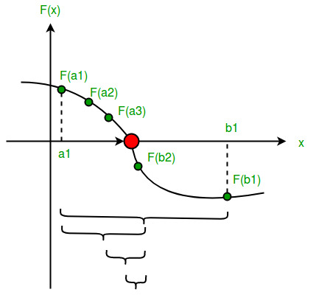
Algorithm:1. Find middle point c= (a + b)/2 .
2. If f(c) == 0, then c is the root of the solution.
3. Else f(c) != 0
A. If value f(a)*f(c) < 0 then root lies between a and c. So we recur for a and c
B. Else If f(b)*f(c) < 0 then root lies between b and c. So we recur b and c.
C. Else given function doesn’t follow one of assumptions.
4. If A or B is satisfied then repeat from 2 till certain accuracy is achieved.

Newton Raphson Method:
Starting from initial guess x₁ the Newton Raphson method uses below formula to find next value of x, i.e., xn+1 from previous value xn.
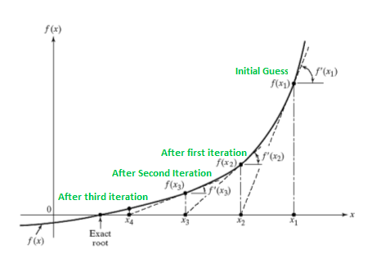
Algorithm:
1. Start the program.
2. Define the function f(x), f’(x)
3. Enter the initial guess of the root , say x₀
4. Calculate x_{n+1} = x_{n} – [f(x_{n})/ f’(x_{n})],
where n = 0, 1, 2, …
5. If |x_{n+1} – x_{n}| < ϵ, ϵ being prescribed
accuracy then go to step 7.
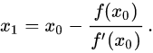
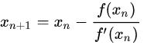
6. Set x_{n} = x_{n+1} and go to step 4.
7. Print the value of x_{n}.
8. Stop the program.

Euler Method for Solving ODE (1st Order):
In mathematics and computational science, the Euler method is a first-order numerical procedurefor solving ordinary differential equations (ODEs) with a given initial value. Consider a differential equation dy/dx = f(x, y) with initialc ondition y(x0)=y₀
then succesive approximation of this equation can be given by:

Algorithm:
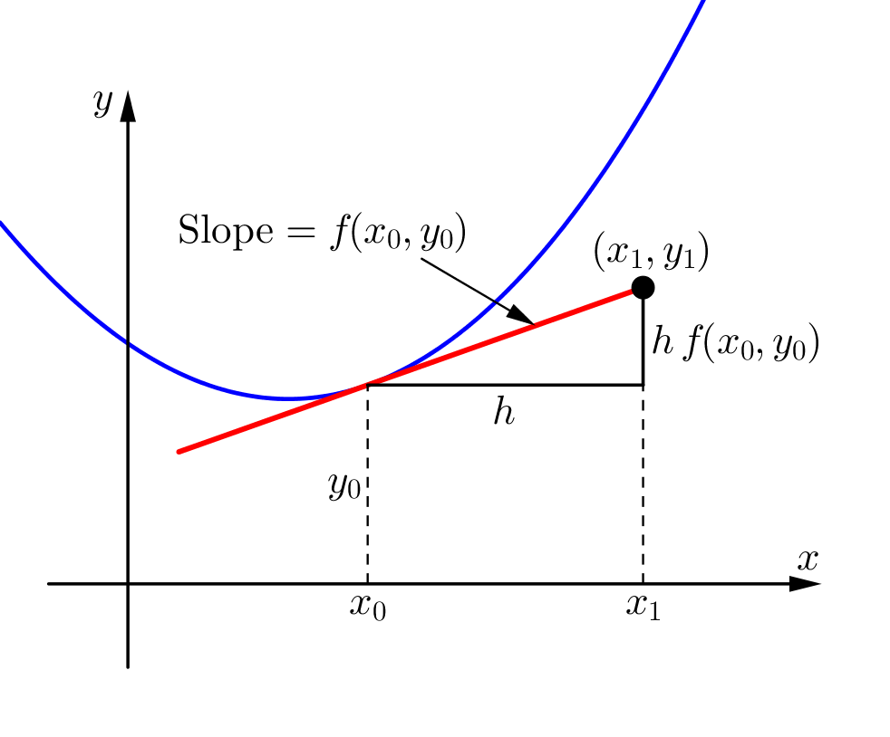
- Define function f(x,y)
- Get the values of x₀, y₀, h and n
*Here x₀ and y₀ are the initial conditions
h is the interval size
n is the interval number
- Start loop from i=1 to n
- y = y₀ + h*f(x₀,y₀)
x = x + h
- Print values of y₀ and x₀
- Check if i < n,
If yes, assign x₀ = x and y₀ = y
If no, goto 7
- End loop i
- Stop the program

